**Validating the Taxonomic and Distributional Status of the Neosho Smallmouth Bass (*Micropterus dolomieu velox*)**

Project Update

*Microsatellite genotyping*

I genotyped a total of 750 SMB fin clip samples at 15 microsatellite loci (Table 1) from the sample distribution shown in Figure 1; this distribution includes all samples collected by Jeff Koppelman et al. as well as samples contributed by Oklahoma State University.

**Table 1**. SMB Microsatellite Information



|  |  |  |  |
| --- | --- | --- | --- |
| Locus | Allele # | Min allele SIZE | Max allele SIZE |
| *Lma 21* | 6 | 154 | 182 |
| *Mdo 2* | 6 | 187 | 207 |
| *Mdo 3* | 6 | 125 | 145 |
| *Mdo 5* | 2 | 190 | 210 |
| *Mdo 6* | 3 | 140 | 160 |
| *Mdo 7* | 2 | 162 | 182 |
| *Mdo 8* | 8 | 210 | 230 |
| *Mdo 9* | 5 | 116 | 136 |
| *Mdo 10* | 2 | 91 | 111 |
| *Msaf05* | 7 | 132 | 150 |
| *Msaf06* | 8 | 96 | 126 |
| *Msaf09* | 5 | 159 | 177 |
| *Msaf14* | 8 | 177 | 243 |
| *Msaf17* | 11 | 89 | 119 |
| *Msaf29* | 12 | 112 | 170 |

**Figure 1**. SMP sampling distribution

After removing samples that failed to amplify in PCR at a majority of loci (>7 loci), and after removing locus *mdo8* due to significant deviations from HWE and linkage equilibrium assumptions, I analyzed a total of 673 SMB fin clips samples. Of those, n = 3 are Spotted Bass collected by Jeff Koppelman et al. Spotted Bass samples contributed by Oklahoma State University have not yet been included in analyses but will be included in our updated results.

*STRUCTURE Analysis*

****All 673 SMB samples were analyzed using Bayesian cluster analysis in STRUCTURE, and the q-plot results are shown below (Figure 2). Before running STRUCTURE, some populations, including Big Sugar Creek, Indian Creek, Caney Creek, Baron Fork, Illinois River, Shoal Creek, and Big Piney River (MO), were divided into several subpopulations according to their GPS data points, and each delineated subpopulation was shown to conform to HWE and linkage equilibrium assumptions.

Results from STRUCTURE (Figure 2) indicated the highest likelihood estimate at K = 2 (cluster 1 in yellow, cluster 2 in green). After running STRUCTURE, populations were manually rearranged such that those assigning mostly to cluster 1 (yellow) were clumped on the left-hand side, and those assigning mostly to cluster 2 (green) were clumped on the right-hand side. Of the total 35 populations delineated, the first 29 represent rivers within the putative Neosho native range, while the last 6 represent rivers within the putative Northern native range.

Putative Northern Range

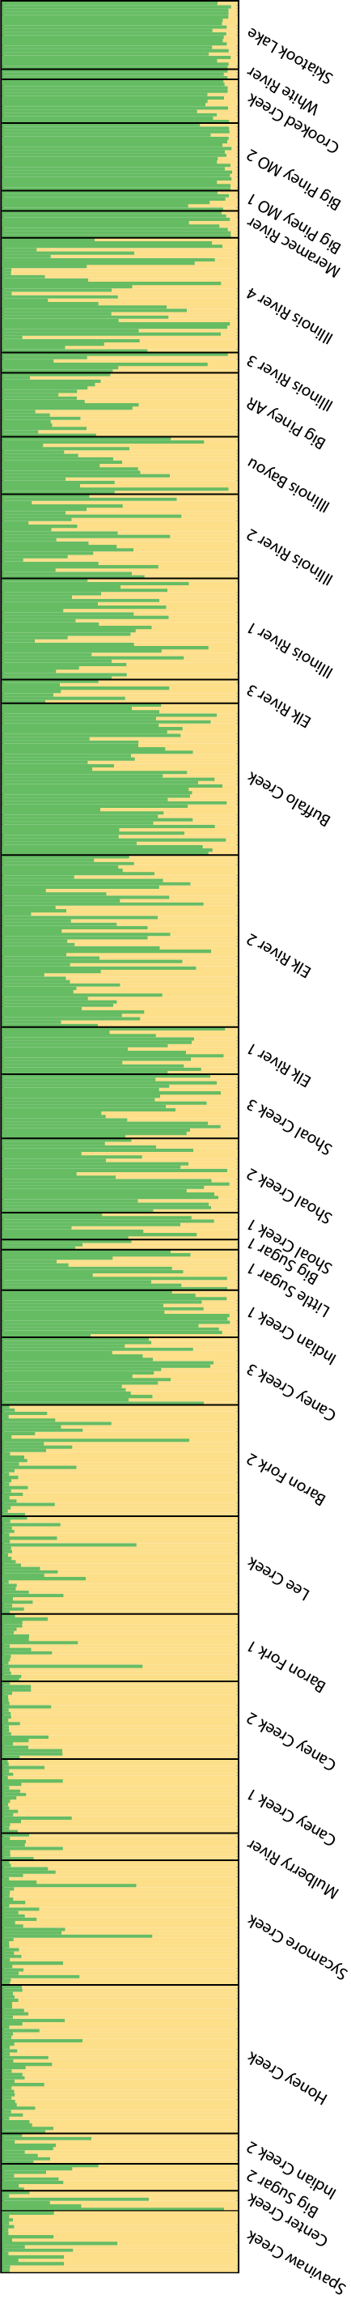

Putative Neosho Range

**Figure 2**. Bayesian cluster analysis using STRUCTURE. Log Likelihood was highest for K = 2, indicating the presence of two likely genetic clusters (yellow and green). The first 29 delineated populations represent rivers within the putative Neosho native range, while the last 6 populations represent rivers within the putative Northern native range.

I calculated pairwise F*ST*values among all populations. My results indicate that the average F*ST* between populations within the Neosho range was 0.085. The average F*ST* between populations within the Northern range was 0.098. The average F*ST* between populations from different native ranges was 0.183.

*Moving Forward*

I recently acquired an additional subset of samples from Stockton Lake and Tablerock Lake in Missouri (both within the putative Northern native range), and I have not genotyped Spotted Bass samples contributed by Oklahoma State University. I will continue genotyping all of these samples and include them in my STRUCTURE analysis.